Sunday 24th May 2020
Reopening Update
Dear Parents & Carers,

Sorry to be contacting you on a Bank Holiday weekend but felt Tuesday was a little late for this update of information.

As you know the school continues to be in regular contact with the Local Authority and Government about the changing landscape in relation to COVID-19. Due to the need for social distancing and the subsequent impact to school capacity this has meant that in the first instance we have needed to prioritise who we can welcome back.
The priority list following Government and Local Authority directives would be as follows:
- Children of keyworkers
- Children who are vulnerable
- Reception
- Year 1
- Year 6
You will also know from my previous letter that we have been working really hard planning and organising the school in order reopen for Reception, Year 1 and Year 6. I was planning on sharing our plans with you on Tuesday as we had got to the point where we were happy and confident in all the risk assessments and plans we had made.

However on the 21st May 2020, the National Government, the Local Authority and Public Health England (PHE) updated their guidance in relation to people in the community who are classified as medically vulnerable.
This medical vulnerability falls into two distinct categories, however the impact of this enormous.

- Those who are clinically extremely medically vulnerable
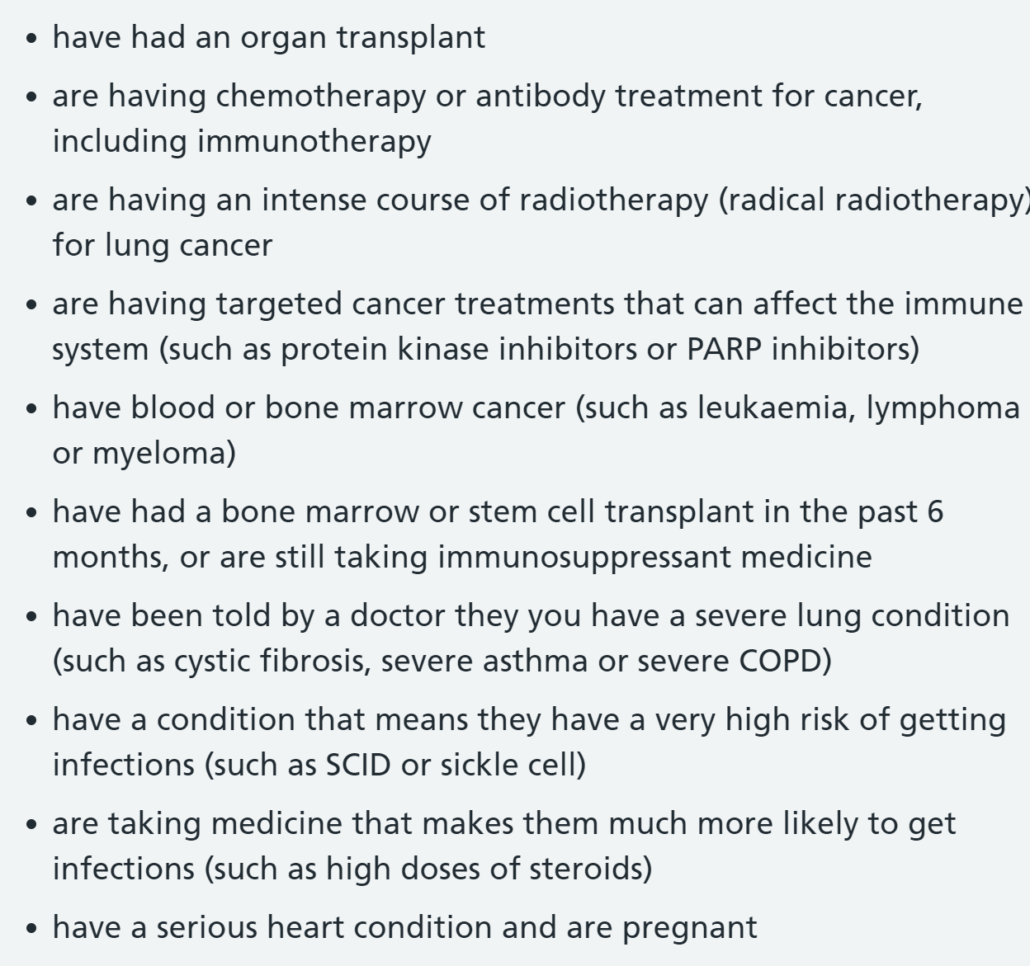
- Those who live with someone who is clinically extremely medically vulnerable

- Those who are clinically medically vulnerable
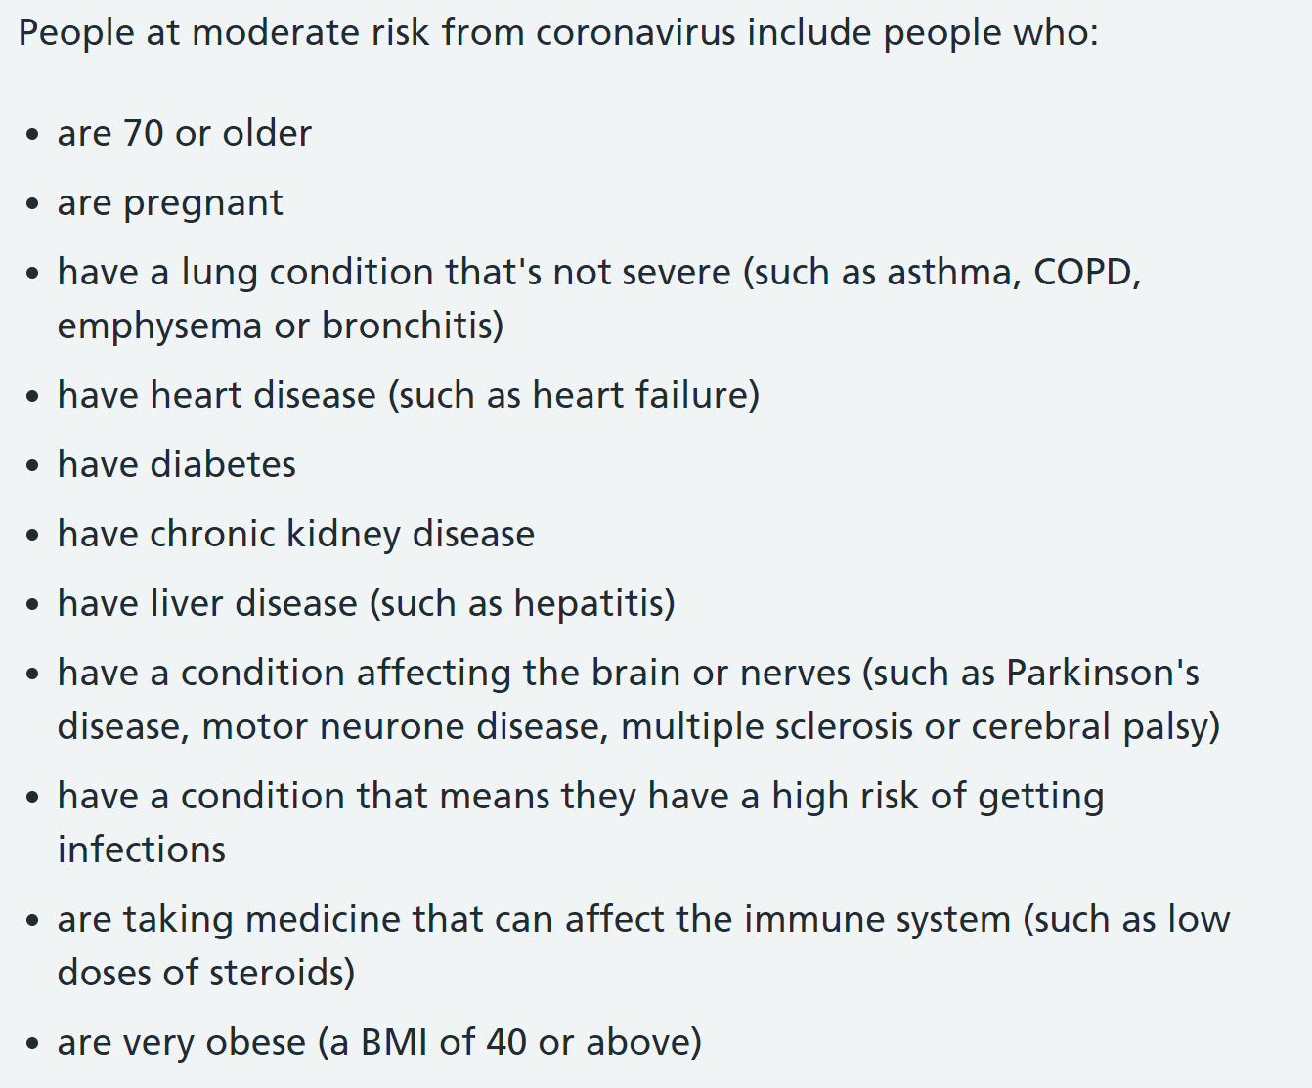
- Those who live with someone who is clinically medically vulnerable.
Further guidance specifically relating to these categories can be found here.

PHE and Sandwell Local Authority have stated that children and adults who fall into any of the above categories should stay at home and therefore not attend school at the moment.
This has changed the landscape significantly and the plan whereby we were hoping to open to a wider cohort of young people has been somewhat undone.

The impact of this guidance has also meant that a significant proportion of the school workforce are unable
to come into work and support our young people due to the increased risk. Based on recent guidance any child or member of staff who falls into one of the above four categories will not be able to attend site due to the increased risk to health. Until the guidance changes or the school leadership team and governing body can manage and mitigate the risk this will remain the case until further notice.

We now need to work closely with families who are keyworkers and who are vulnerable to identify what we can continue to achieve based on these new constraints. However, at the heart of this is the safety and wellbeing of our young people and staff. So for example if you or anyone in your household has asthma your child will no longer be able to come to school.

When the advice changes we have made excellent preparations so we can get up and running to
more of you and in a timely fashion. This has been an upsetting set back to our young people, families and our staff. We really were looking forward to seeing more of you back in school. However, we must continue to do the right thing and follow government advice. I would like to thank you all for completing the parent survey for Reception, Year1, and Year 6, don’t forget it closes today.

In the meantime, the school is still open only for vulnerable pupils and the children of critical workers,
unless they fall into the aforementioned medically vulnerable categories. Once I know how many members of staff can work under the new guidance I will be in touch with what children I can open up to as this will now be greatly reduced. We know some employers will be encouraging you to return to work, but we’re not in a position right now to extend places to other children until we receive further government guidance and have a school setting that is COVID secure and we have an increased capacity.

Again it is with a heavy heart I am sending this letter and really wish it contained more positive news. I will be in touch as soon as I know more.

Take care everybody, keep safe
Best Wishes
Mrs N Crozier


This Photo by Unknown Author is licensed under CC BY-SA-NC

